# Aranya Solutions - Communications Channel Grant

*** THE NEW SECTIONS ARE AFTER THE HIGHLIGHTED COPIED SECTIONS****

## Mission & Vision

*** COPIED FROM OVERVIEW ***

**Mission Statement:**

Aranya Solutions mission is to enrich quality of life within targeted economically challenged and developing areas such as Nepal. Aranya Solutions develops systematic changes with a focus on localization serving as a bridge to resources and provide necessary infrastructure. Our method is to assist communities to implement environmentally friendly building and agricultural methods, life skills workshops, local business development, leadership training, education initiatives, and capacity building.

**What We Do:**

1. **Sustainable Land Use**

We support sustainable agriculture techniques and education to empower local resources, creating economic opportunities. . 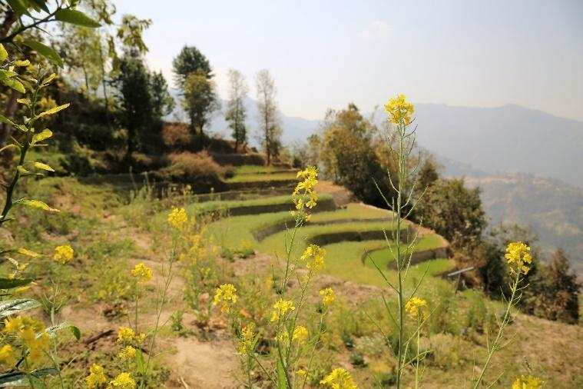

1. **Community Development**:

Through partnering with communities, organizations and sometimes cities, we identify assets and resources to coordinate efforts between leaders, projects and organizations together for a stronger, more vibrant community. We help with structure, systems, asset mapping, programming, stakeholder analysis and more.  We focus on at-risk youth, women’s empowerment and life skills education – including capacity building.

1. **Leadership Skills**

We help entities sustain themselves through organizational support to improve conditions and functionality. We provide training in leadership development, emotional intelligence, critical thinking and communication skills.

**Projects**

**Nepal Village Rebuilding -** Digam Village Community Development – We are building a community center, agriculture training and livelihood programs for this community who was deeply affected by the 2015 Earthquake.

**Leadership Development** – Trainings on emotional intelligence, communication skills, compassion and embodied empowerment. Trainings are both in-person and on-line. The constituents will be new political leaders and people interested in increasing their leadership skills. We will collaborate with a few partners in Nepal, India and other countries.

1. ICA – Institute for Cultural Affairs (Nepal branch). A leader in International Community Development
2. The Relief Trust – A Nepal nonprofit that does trauma relief work, leadership and life skills trainings with leaders and rural areas in Nepal.
3. Sanjay Ghanghaw – Mentor for the Leadership Training, a Human Resources and Organization Development professional based in Mumbai, India.

**The Story - Background:**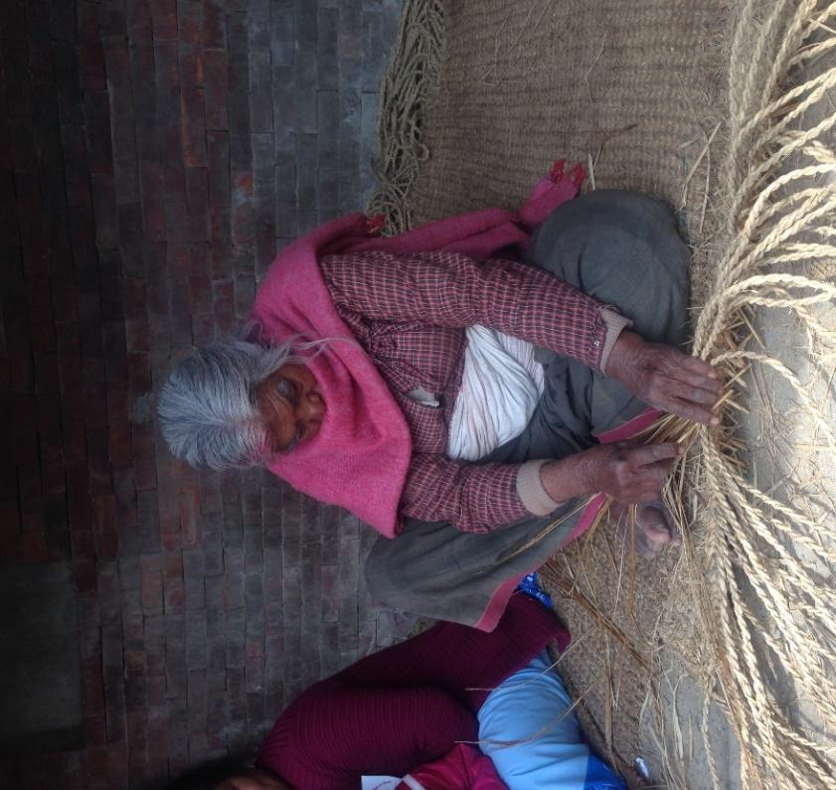

The inspiration for developing a nonprofit came during Katrina’s international travels in 2017 doing research on the international community development field. She wanted to do work aligned with sustainable land use and utilize her skills as a coordinator and community organizer.  Aranya means “abundant forest” in Sanskrit, signifying plenitude, generosity, resourcefulness and prosperity.  She recognized that her skills and network is full of resources that can be used to help coordinate people and lands to be self-sustaining and contribute to their larger communities’ livelihoods. Recognizing how hard it can be for start-ups to find the resources available, she began to envision Aranya Solutions as a nonprofit serving as a framework for organizational support for sustainable community development. Aranya Solutions provides education in administrative and organizational skills, and could become a forum to accept donations for scholarships and needs. We are collaboration-based, working in partnership with organizations and local institutions including schools, the Government and International Nongovernmental Organizations (INGO’s). Katrina shared “As I talked with locals, it became clear that there is a need for smaller more agile organizational support with local-level projects. This is where Aranya Solutions fits, by understanding and being responsive to local needs by being a bridge to resources and organizational support.” The first project was identified in Nepal, Digam Village, that fit our criteria and is a community in dire need where no other organization’s were working, thus our impact will be significant. It quickly became apparent that we need to have our own nonprofit to properly coordinate the first and many more projects focused on community and sustainability development for long lasting sustainable solutions. Now is the time where we can create an organization to have tremendous impacts with people in need.

Aranya Solutions is now a nonprofit registered in the state of Montana 2018 and recognized as a 501(c) (3). We formed a nonprofit to serve the underserved, starting our work in Nepal after seeing the needs for more support on the ground and for fundraising. Aranya Solutions serves organizations and communities dedicated to making the world a better place. We create and facilitate strategies for efficiency.

## Philosophy & Approach

*** COPIED FROM OVERVIEW***

Aranya means “Abundant Forest” in Sanskrit and that is what we strive to achieve both literally and metaphorically. We have an ecological mindset in our approach, where we think and act like a forest ecosystem, identifying where the levers for support are needed and bring resources to fulfill the needs – pollinating like bee’s. We act in collaboration with our web of partners to provide access to assets that bolster cultural resilience, sustainability impact and livelihood. We work together to develop systematic improvements with a focus on localization, serving as a bridge to resources and providing necessary infrastructure.

This nonprofit has been formed to fill an important niche of working directly with the community in collaboration with local organizations and providing leadership development skills for long term public health and sustainability. The purpose of having a nonprofit in the USA is to raise funds from the States to bring to places that are in greater need, as a direct channel for fundraising efforts for maximum impact.

Our Ethos – “Service Above Self”

We believe that for service to be true it must also be embodied, and thus connected with our whole being. This is the leading edge of the sustainability movement: the realization that no matter how many solar panels we install, how many green products we consume, how much CO2 [and Methane] we remove from the atmosphere, we will not be living better lives if we do not transform ourselves, our lifestyles, choices and priorities. Sustainability is an inside job, a learning journey to live lightly, joyfully, peacefully, meaningfully.

### **We Serve The Underserved**

We connect with our stakeholders on a local level. We go where we are asked to go and we fill in gaps and communities that were overlooked from other programs attempt to scale up, leaving 10% of the people behind. We help these people left behind. We also provide leadership trainings and awareness of these gaps so more resources can be identified to address all the needs and people, not just some. Some villages don’t even know about potential resources, or live at far distances from such needed disaster relief.

By forming relationships, identifying assets and needs we can help bridge some of these gaps. To name some examples: we’ve connected the villages with support from the Institute for Cultural Affairs in Nepal (ICA Nepal) so Digam Village can have assistance in rebuilding their school and community center, which was destroyed in the 2015 earthquake. We’ve connected the Villagers to teacher trainings so that they can learn to teach their own primary education and functional adult literacy in the village again. We bolster their livelihoods efforts by connecting the villagers with agriculture training and regional markets and help them with information and resources they deem pertinent to their entrepreneurship.

**Scope of Work**

Interventions for Social Change

1. Individual

2. Teams and groups

3. Community / Localization

## Needs Assessment

**COPIED FROM OVERVIEW***

In developing countries like Nepal farmers suffer from lack of education, training, tools, techniques and modern equipment that hinders in increasing productivity, which affects economic opportunities. Individuals and small organizations working on local/ village levels lack connection, resources and knowledge on how to connect with donors and funders. Community development and education has been a major challenge for some villages in Nepal, many people leave school before finishing grade 10… and in our focus area, many children walk over 1.5 hours to school. Girls are often married at age 11 and have children then become young mothers, thus they do not even complete grade 8- and have not formed critical thinking nor life skills. Because of poor education, there are not many job opportunities, so many young people immigrate to work in gulf countries, leaving holes in their home community. They come back broken by the challenging work life and economy of the gulf countries after doing hard labor working 12 hours a day to earn only $200 USD a month. Many youth also go into sex work both in Nepal and in neighboring countries, not recognizing the long term/ lifelong health, emotional and mental impacts from these actions.

## 

## Communications Platform Program Description

Our communications channel is a platform for (goal 1) sharing the stories of the villagers, (goal 2) involving a community of supporters and (goal 3) promoting leadership that inspires . Each of these goals has a different constituency in mind. Goal 1 is focused on our stakeholders, the villagers, and their needs for communication and being able to tell their story. Goal 2 is focused on the supportive community, people that want to make a difference by supporting our mission with funds, resources and awareness. We want to help our supporters experience the meaning of the work they are funding, because by doing that we make the project more sustainable in that we are meeting a tangible need for them to live a life of purpose. Goal 3 is focused on inspiring leaders and leaders in training that are aligned with Aranya Solutions vision and mission.

The idea is that the communications platform helps create the conditions for sustainability of the Aranya Solutions organization by nurturing an ecosystem of vibrant lasting relationships between our stakeholders, our supporters and our network of pollinators/leaders. The end goal is for this living web of meaningful relationships to ultimately support the rise of a more meaningful, compassionate, culturally diverse world.

### Goal 1 - Sharing The Stories Of The Villagers

The first goal of our communications channel is to serve as a platform that amplifies the voice of those who are not being heard. By definition our stakeholders in rural areas are people that have fallen through the cracks of globalized capitalism, local governments, Non Governmental Organizations and International Non Governmental Organizations. By sharing the story of the villagers - only when they want to share of course - we give them a voice and raise awareness about their needs, culture and offerings to their region and other communities beyond.

The goal is to raising their visibility in such a way for the villagers to attract potential partnerships and beneficial livelihood opportunities. Aranya Solutions acts as a pollinator creating a buzz - a web of relationships to help the villagers protect their culture from the erosive effects of globalization by helping them find meaningful and compatible sources of livelihood and improvement of living conditions. In absence of such relationships market forces push the young able-bodied people in the village to move to gulf cities for work which has been eroding the cultural sustainability of the village. By sharing the villager’s stories and thus connecting them to sources of support and livelihood we can give the village a chance to maintain its integrity and provide its youth the choice to stay with their family while also having a dignified standard of living.

|  |  |
| --- | --- |
| Activities | Medium |
| Short vignettes and interviews about different aspects of our stakeholders day-to-day life. At least one per quarter. | Videos on Facebook, Youtube and Patreon. |
| Stories and pictures about villager and Nepali culture. At least one per quarter. | Photography collections on instagram, Facebook and on our website. |
| Inspirational stories about the innovation, craftsmanship and creative success of the villagers. At least one per quarter. | Profile articles on our website, linkedin and other pertinent blogs. |

### 

### Goal 2 - Nurturing Community Support

A second purpose of the communications platform is creating and sustaining an audience of supporters by describing and celebrating the amazing work that we are doing together. In a world so full of negative news we want to embody the power of collaboration and positive change. Leveraging a responsive communications platform will allow more people to see live updates of actions on the ground, thus inspiring them to care, to share, to help and contribute. Today’s technology allows for a new kind of interactive philanthropy, where day-to-day information updates, images, live-feeds, and tweets might ultimately become more important to donors than after-the-fact reporting. A crucial part of Aranya Solutions’ pollinator effect is engaging in innovative platforms like Patreon and Kickstarter to create a more intimate and seamless way for individuals to become supporters and funders.

To captivate a large number of viewership and to inspire them to support we will highlight the stunning vistas of the Himalayan landscape by using cutting edge 360 VR footage. This footage would allow anyone with a cell phone to experience our video footage in 360 degrees by simply moving their phone around them. This functionality is already part of Youtube as it is. Additionally for the growing number of VR users they could go a step further and actually have the experience of being there (at least virtually). We believe that this functionality is not far fetched since these devices are being sold by the millions and Youtube already has the functionality backed in. A VR camera only costs about $100 dollars more than a regular one, so this also doesn’t require an extraordinary investment. Nevertheless, using this new technology with this subject matter will create a buzz, which means being part of articles, interviews, tech trade shows and meetups that will further increase the visibility of our project.

In our content we will strive to tell more personal stories of accomplishment and life. Additionally we will have a plethora of fascinating subjects to explore within the rich culture and history of Nepal. Nepal is also politically interesting in that it is a relatively new democracy that has cutting edge liberties like the legal acceptance of gay marriage and even gender-non-binary citizens for example.

We will tend relationships with strategic social media outreach utilizing the strengths of the different services (Twitter, Facebook, Instagram, etc…) to reach new audiences. We will use Google Analytics with UTM code to verify where we are truly getting more engagement and react accordingly. Part of this is also connecting to a responsive personalized website experience that creates a central hub for our compassionate community.

|  |  |
| --- | --- |
| Activities | Medium |
| Quarterly Newsletter with project activity and content updates. We will add a short video as part of the newsletter whenever possible for a personal touch. | Full HTML newsletter will be produced and distributed in and through CiviCRM. |
| Live feeds with on the field updates and Question and answer when conditions are conducive but at least twice a year. (Internet availability will be a limiting factor.) | Live feeds will take place on Facebook live or Youtube live. (Depending on what gets better response.) |
| Inspirational interviews exclusive on Patreon once a quarter. | Videos on Patreon. |
| Twice a week (at least) social media engagement with stakeholders, supporters and leaders. | Social media engagement on Facebook and Twitter. |
| Development of a responsive personalized website. Our website platform and will have different levels of accounts with corresponding dynamic pages. | We will use the open source Wordpress framework with our own custom PHP code for added functionality. |

### 

### Goal 3 - Promote Leadership That Inspires

We want to give voice to change makers doing the work in a variety of ways. We want to learn from the experience and wisdom of thought leaders in the areas we serve and around the world. To accomplish this we will be doing interviews of people who inspire us.

The goal is to inspire people that strive to innovate and make an impact in the leadership realm with the content that we curate. We call these leaders “meaning entrepreneurs” ,because they create change with purpose in mind. A “meaning entrepreneur’s” bottom line is about enriching people’s lives and creating sustainable outcomes.

This program goal dovetails with an important part of Aranya Solutions array of services which is our leadership trainings. We want to empower the trainees of our training program as well and a broader audience to connect with a larger movement of change makers. We aim to be a platform for positive transformation with resources that empower and liberate. Here also our website can serve as a useful platform for education resources where we will have course materials, articles, TED Talks, etc. We will also have a Forum where the network of people who go through the leadership experience can communicate and learn from each other.

|  |  |
| --- | --- |
| Activity | Medium |
| Monthly informational vignettes about pertinent influencers. | Youtube, Patreon and LinkedIn videos. |
| Quarterly interviews with pertinent influencers. (More frequent when possible) | Exclusive on Patreon |
| Articles with professional resources for leadership. At least per quarter. | Blog posts on our site and LinkedIn. |
| Education platform with tools for teachers, students and administrators. | Custom coded leadership education platform hosted on our website. |

## 

## Milestones and Indicators for Accountability

The overall project is multi-faceted. We are collaborating with The Relief Trust, The Rotary Club Nepal and Institute Cultural Affairs on the education, agriculture, livelihood and rebuilding efforts. This grant for the Communications Platform Program describes a part of the whole. This means that mechanism of accountability and clarity about responsibilities will be crucial. We’ll employ a whole array of financial reports, questionnaires, direct accounts from our stakeholders, Google Analytics statistics, donor relationship management reports and a yearly census. Additionally, the Institute of Cultural Affairs will be conducting reporting and deploying 3rd party oversight. The below chart describes the projected impact, outcome, output, input and activities for the communications platform program specifically. It also includes objectively verifiable indicators, means of verification and notes about risks and assumptions. We are striving to create a tightly organized program with accountability mechanisms, while also being responsive to potentially shifting realities on the ground.

### Logical Framework of The Communications Program:

|  |  |  |  |
| --- | --- | --- | --- |
| **Communications Program** | **Objectively Verifiable Indicators** | **Means of Verification** | **Risk and Assumptions** |
| Impact   1. Cultural resilience of the villager’s way of life. 2. Improvement of the standard of living. 3. Sustainability of the project through it’s duration. 4. Unleashing a chain reaction of other similar projects. | 1. Increase in the number of young adults who find work without leaving their home in the village. 2. Increases in nutrition and household income. 3. Surplus of financial and in-kind donations to meet the project’s needs. 4. Third party foundry of aligned projects. | 1. Yearly census. 2. Direct accounts from villagers. 3. Financial statements and “Gains and Loses” reports. 4. Surveys of Leadership program Alumni. | 1. There’s a risk in not being able to reach the right audience or not enough of them to make an impact. 2. There’s a risk that extraneous circumstances are too strong to counterbalance. 3. We assume that people will be inspired to support this project if they hear about it’s impact. |
| Outcomes   1. More young able-bodied villagers can find a way to make a good way to make a living in the village. 2. Connect the village with resources to improve the standard of living and improve disaster resilience. 3. Communications platform reaches a large audience that finds meaning in supporting our efforts. 4. Communications platform inspires new leaders to become change makers and forge new meaningful endeavors. | 1. Increase in the number of young adults who find work without leaving their home in the village. 2. Increases in nutrition, household income and durability of buildings. 3. Amount of viewers and subscribers. 4. Third party foundry of aligned projects. | 1. Yearly census. 2. Direct accounts from villagers. 3. Patreon and Youtube statistics as well as Google Analytics. 4. Surveys of Leadership program Alumni. | 1. We assume that enough young villagers would prefer to stay in the village if they had a way to maintain a good livelihood there. 2. We assume that they are interested (as they have described being) in following through with connecting to resources. 3. There’s a risk that there are too many distractions for people to tune into our project. |
| Outputs   1. 50 young villagers find meaningful livelihood in the village and choose to stay with their families. 2. 200 Villagers have enough livelihood opportunities to have at least 2 meals a day. 3. 200 Villagers have enough livelihood opportunities to live above the poverty level of 1$ a day. 4. 17’000 potential supporters are exposed to (view) our content. 5. We have at least a 2% conversion rate from viewer to suporter resulting in 340 supporters. 6. Supporters average $25 dollars of monthly support resulting in $102’000 annual revenues. 7. 1000 views of our video and online resources from change makers and trainees. | 1. Amount of young villagers who leave for outside work every year drops by 50. 2. Frequency of meals. 3. Number of villagers living in financial duress. 4. Amount of viewers and subscribers on the media platforms. 5. Number of active supporters. 6. Average donation amount and yearly revenue. 7. Amount of viewers and subscribers on the media platforms and website. | 1. Yearly census. 2. Direct feedback from villagers gathered quarterly. 3. Quarterly social media platform statistics and Google Analytics reports. 4. Quarterly donor management reports and Patreon dashboard. | 1. We assume that (as the villagers have stated) it would be a positive thing for the young villagers to find a way to stay in the village because it would support the socio-economic fabric of the village. 2. We assume that increasing the living standard and reducing starvation in the village will be beneficial in multiple ways. 3. 17’000 viewers and 2% conversion rates are ambitious goals and will require good compelling content to achieve. We believe that highlighting the stunning views of the Himalayas, the interesting Nepali culture as well as an engaging narrative will accomplish this level of success. 4. Depending on the churn rate of subscribers measures will have to be put in place to inspire continued support. Donor engagement will play an important role. |
| Activities   1. Quarterly Newsletter with project activity and content updates. We will add a short video as part of the newsletter whenever possible for a personal touch. 2. Stories and pictures about villager and Nepali culture. At least one per quarter. 3. Inspirational stories about the innovation, craftsmanship and creative success of the villagers. At least one per quarter. 4. Quarterly Newsletter 5. Live feeds when possible. Will attempt 2 per year. 6. Inspirational interviews exclusive on Patreon. At least one per quarter. 7. Twice a week (at least) social media engagement with stakeholders, supporters and leaders. 8. Development of responsive personalized website. 9. Monthly informational vignettes about pertinent influencers. 10. Quarterly interviews with pertinent influencers. (More frequent when possible) 11. Articles with professional resources for leadership. At least one per quarter. 12. Education platform with tools for teachers, students and administrators. | Inputs   1. Part time communications director. Workload breakdown:    1. One content deliverable a week. 10 hours.    2. 4 hours a week of social media posting and responding.    3. 2 hours a week of website updates.    4. 80 hours of coding to develop education platform. 2. Flip camera for interviews and it’s respective accessories. 3. 360 degree VR camera to capture stunning himalayan vistas and it’s accessories. |  | Pre-conditions  The equipment needs to be purchased in order for the footage to be created. |

# 

# 

# Sustainability of the Project

This communications platform program has a unique role within the project to ensure that our efforts are financially self-sustaining. Goal 2 of the program, Nurturing Community Support, is focused on creating a dynamic web of funding support. By growing a monthly subscription based following on Patreon we will go a long way towards creating a reliable grassroots revenue stream. Additionally, the communications platform program’s Youtube and social media exposure will increase the visibility of the project and will ultimately help create a diversified fundraising portfolio by introducing us to other resources.

Our goal is to increase our viewership to 17’000 viewers and our grassroots support to 340 monthly supporters. We are expecting that with an average $25 monthly donation we can meet our grassroots fundraising needs of $100’000 annually. This web of grassroots support will be instrumental in helping Aranya Solutions in day-to-day operations flexibility, allow us to create a 6 month rainy day fund and to better navigate restricted funds grants without having to resort to credit lines.

As a young organization it can be stressful and outright crippling to live from restricted grant to restricted grant. The communications platform program is our best hope to ensure that this organization and the impact it creates can get the diverse support it needs to succeed. Ultimately, our goal of the project is to help the villagers in Digam, especially women, to find their way to culture and livelihood resilience and to rebuild their infrastructure. The overall project has a 300’000 budget, which is being funded by the Rotary Club Nepal and the Institute of Cultural Affairs. This communications platform program grant request of $22,225 would ensure that we can support the project in the right ways to celebrate our stakeholder’s (the villager’s) successes, inspire new change makers and would ultimately allow the overall project to thrive.

## Budget

|  |  |  |  |  |  |
| --- | --- | --- | --- | --- | --- |
| **Communications Program Budget Items** | **USD** | **Budget Breakdown Detail (in USD)** | **Description Detail / Notes** | **Category** | **URL** |
| Simple Camera and accessories | $312 | Camera $159  Accessories and insurance $153 | To use for interviews and vignette footage. | Equipment |  |
| Camera for 360 and VR content. | $472.71 | Camera $399  Accessories $72. | Ricoh - Theta V  360 degree camera to deliver stunning Himalayan vues. | Equipment | https://www.bestbuy.com/site/ricoh-theta-v-360-degree-digital-camera-metallic-gray/6096201.p?skuId=6096201&cmp=RMX&extStoreId=450&ref=212&loc=1&ksid=246590c8-bd5b-4d88-9d46-24353eb780dc&ksprof_id=14&ksaffcode=pg174715&ksdevice=c&lsft=ref:212,loc:2 |
| Adobe Suite | $240 | $20 a month discounted subscriptions for a year. | Adobe Photoshop, Illustrator, Premier and After Effects | Software |  |
| Part time communications director. | $19’200 | Workload breakdown:   * 1. 10 content deliverables per quarter plus two live feeds a year. 10 hours a week.   2. 4 hours a week of social media posting and responding.   3. 2 hours a week of website updates.   (Total 16 hours a week at 25$ an hour. $1600 a month.) | 1. Quarterly Newsletter with project activity and content updates. We will add a short video as part of the newsletter whenever possible for a personal touch. 2. Stories and pictures about villager and Nepali culture. At least one per quarter. 3. Inspirational stories about the innovation, craftsmanship and creative success of the villagers. At least one per quarter. 4. Quarterly Newsletter 5. Live feeds when possible. Will attempt 2 per year. 6. Inspirational interviews exclusive on Patreon. At least one per quarter. 7. Twice a week (at least) social media engagement with stakeholders, supporters and leaders. 8. Development of responsive personalized website. 9. Monthly informational vignettes about pertinent influencers. 10. Quarterly interviews with pertinent influencers. (More frequent when possible) 11. Articles with professional resources for leadership. At least one per quarter. | Personel |  |
| Web Platform Development | $2000 | 80 hours of coding to develop education platform. | Education platform with tools for teachers, students and administrators. | Personel |  |
| **Total for 12 months.** | **$22,225** |  |  |  |  |